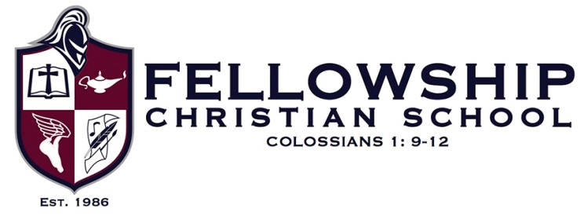

Fellowship Christian School is a Christ-centered, college preparatory, independent, non-denominational covenant school that serves students in grades Pre-K-12. Our vision for students includes the integration of a Biblical worldview into a curriculum where character, values, and essential life skills are emphasized and modeled by a professional and dedicated faculty. This Christian philosophy of education is at the core of all areas of study. A rigorous academic program is offered including strong co-curricular offerings with successful athletic and fine arts programs. As a Christ-centered school, students are taught how to integrate Biblical truth and learning into their daily lives to impact the culture for Christ.
Fellowship Christian School nurtures and educates the whole child — heart, mind, body and soul — and provides a balanced, yet challenging college-preparatory curriculum.

Job Title: Middle/High School English Teacher

POSITION OVERVIEW
This faculty member will join a collaborative learning community, focused on the school’s mission, to partner with Christian parents in the education of their children, in order to raise up generations of students who embrace biblical truth, strive for academic excellence, demonstrate discipline and exhibit leadership and influence in their homes, churches, and communities.

In addition to Biblical integration, our English department seeks to educate students how to think critically and question appropriately through teaching reading, writing, and vocabulary.

In fulfilling our mission to nurture and educate the whole child, Fellowship Christian School hires and retains passionate, talented, diverse educators to offer a rich and engaging curriculum, preparing our students to be lifelong learners and citizens well equipped to address local and global challenges.

JOB REQUIREMENTS
- Incorporating Biblical Integration into all curriculum areas
- Instructing students in subject content along with designing engaging lessons and classroom activities
- Demonstrating the ability to successfully implement differentiated teaching strategies
- Investing in the lives of the students and building genuine, teacher-student relationships
- Attending and participating in faculty meetings and other assigned meetings and activities according to school policy
- Demonstrating accurate, up-to-date knowledge of content
- Managing the classroom environment in a way that optimizes the students’ learning
- Maintaining regular, professional communication with students and parents regarding students’ progress
- Working cooperatively with English teachers of different grades to ensure vertical alignment within the curricula
- Strong organizational skills
- Excellent verbal and written communication skills
- Solid understanding of learning challenges as well as the ability to develop and employ strategies to help those students
- Ability to use technology effectively

In addition to experience and a strong educational background, successful candidates demonstrate a love of working with children, an engaging teaching style, the ability to interact well with parents and colleagues, and a willingness to create and promote an inclusive learning environment.

Qualifications
- Undergraduate degree in English Education or its equivalent
- Masters degree preferred
- Preferred 3 years teaching experience in your field

Duties and Responsibilities
- Teach five sections of Middle or High School English
- Co-teach a 2 week immersive Winterim class during the first two weeks in January

Equal Opportunity Statement
Fellowship Christian School does not discriminate on the basis of race, age, sex, color, or national/ethnic origin in its hiring practices, admissions policies, administration of its educational policies, scholarship programs, athletic programs, and other school-administered programs.

