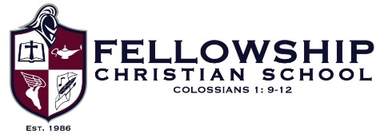

MS STEM/Robotics/Computer:

Job description
Fellowship Christian School has an opening for a middle school STEM/Robotics/Computer teacher for the 2021-2022 school year. This position would be leading our middle school robotics program as well as teaching our 6th and 7th grade computer classes and an 8th grade Intro to STEM class.

FCS is a college prep K4-12th grade school of approximately 900 students. Our aim is to prepare students to excel in any field God has gifted them for with a strong Biblical foundation.

Job requirements
- Incorporating Biblical Integration into all curriculum areas
- Strong understanding of STEM courses, Microsoft Office and VEX Robotics
- Instructing students in subject content along with designing engaging lessons and classroom activities
- Demonstrating the ability to successfully implement differentiated teaching strategies
- Investing in the lives of the students and building genuine, teacher-student relationships
- Managing the classroom environment in a way that optimizes the students’ learning
- Maintaining regular communication with students and parents regarding students’ progress
- Working cooperatively with colleagues of different grades to ensure vertical alignment within the curricula
- Strong organizational skills
- Excellent verbal and written communication skills

Minimum Education Required
- Undergraduate degree in Computer Education or its equivalent
- Current ACSI or State Certification in Middle Grades Computers

Minimum Experience Required
- 3 or more years preferred

